Revelation Lesson Eight
Walk Through the Bible Series – Truth Sowers Life Group
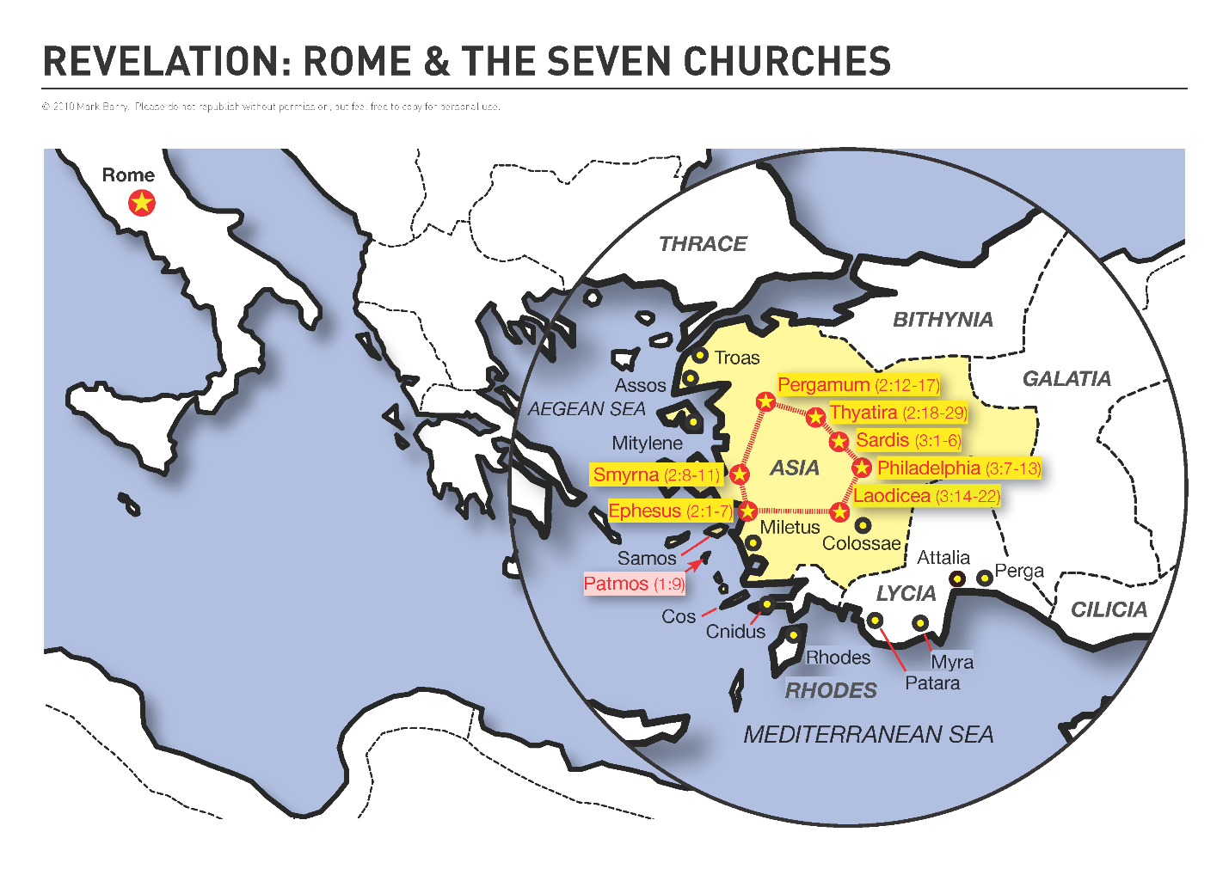
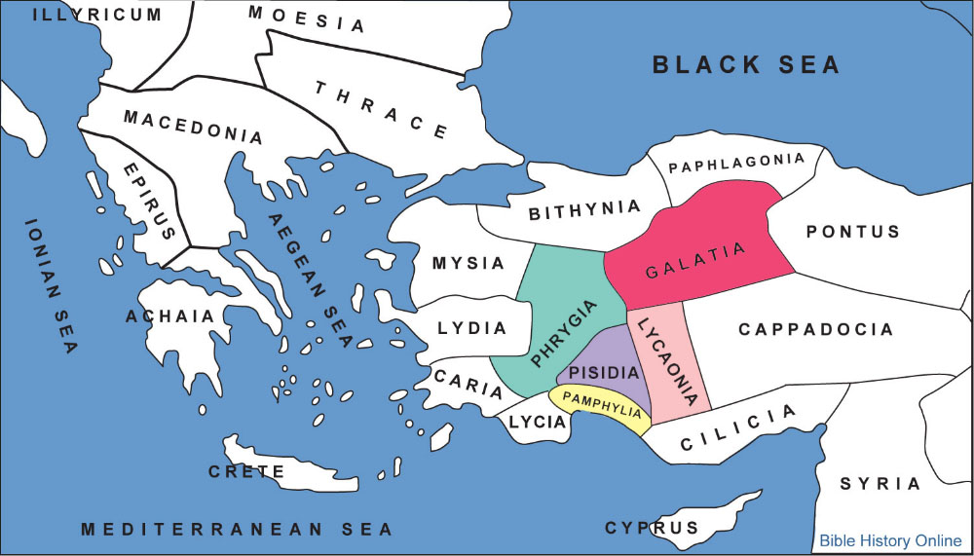
At the time of the writing of Revelation, Churches had been established in the regions of Phrygia, Pisidia, Pamphylia, Lyaconia and Galatia.
http://www.JayMc.com/truthsowers/lessons/Revelation/Images/AsiaMinorMap.docx

