Truth Sowers
Ages and Dispensations
Lesson Two

Last week, we began our study on “Ages and Dispensations.”

This study is setting us up for our “Walk Through the Bible”.

Dake’s Definition of “Dispensation”
“,,,an administration, stewardship, or guardianship. It refers to a moral or probationary period in angelic or human history during which God dealt with angels or human beings according to a particular test or responsibility, under which each was to remain true to his trust of administering affairs for God under His direction.

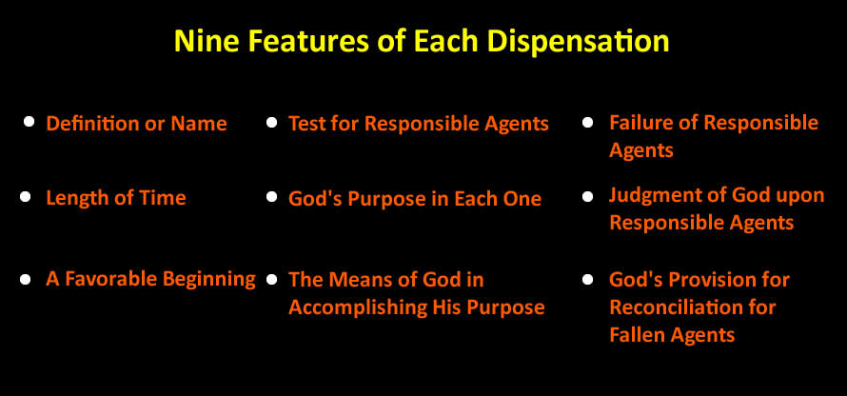

When these nine points regarding each age or dispensation are understood, then God's plan for man as a whole becomes clear. Each dispensation has its own particular beginning and ending; each is characterized by distinctive principles of God's dealings; each has a favorable beginning; each has a definite test; and each ends in failure and judgment, except the final and eternal one.

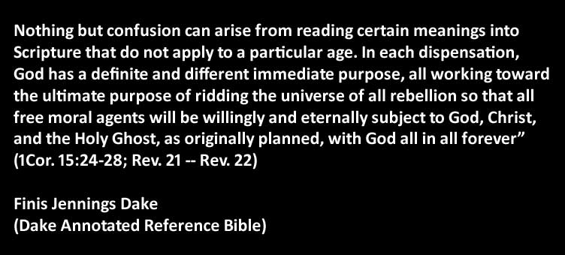

Last week I talked about the “Eternal Past”. During the Eternal Past;

- God planned the ages
- Planned the Kingdom of God
- God created the angels
- God created the heavens (the universe with all its galaxies, stars, planets, suns, etc. and the earth (Genesis 1:1)
- At some point, Lucifer was ruler over this earth
- Satan rebelled and was cast into earth
  - Luke 10:18
And he said unto them, I beheld Satan as lightning fall from heaven.
  - Some scholars believe there was a battle in the heavens and that our moon was destroyed in this battle.
  - Dake believes more angels were put over other planets in our universe. I find no scriptural evidence supporting this view.
  - Scientists believe an asteroid or comet crashed into the earth in what is now, the Yucatan Peninsula. This event is called Chicxulub because one of the nearest towns in Mexico.
  - They believe it was such a catastrophe that it destroyed all living things and ushered in the “Ice Age”. Could it be that it was actually Satan and this is where he was cast into the earth?

We get a picture of what the earth looked like after Lucifer’s flood in Jeremiah.

Jeremiah 4:23-26 (KJV)
²³ I beheld the earth, and, lo, it was without form, and void; and the heavens, and they had no light. ²⁴ I beheld the mountains, and, lo, they trembled, and all the hills moved lightly. ²⁵ I beheld, and, lo, there was no man, and all the birds of the heavens were fled. ²⁶ I beheld, and, lo, the fruitful place was a wilderness, and all the cities thereof were broken down at the presence of the LORD, and by his fierce anger.

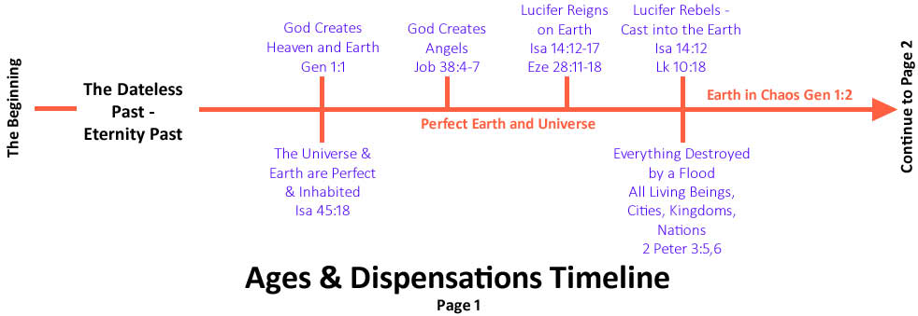

Lucifer’s Reign

Isaiah 14:12-17 (ESV)
¹² “How you are fallen from heaven, O Day Star, son of Dawn! How you are cut down to the ground, you who laid the nations (Heb. goy – How you would address a heathen nation) low! ¹³ You said in your heart, ‘I will ascend to heaven; above the stars of God. I will set my throne on high; I will sit on the mount of assembly in the far reaches of the north; (God sits on the sides of the north.) ¹⁴ I will ascend above the heights of the clouds; I will make myself like the Most High.’ ¹⁵ But you are brought down to Sheol, to the far reaches of the pit. ¹⁶ Those who see you will stare at you and ponder over you: ‘Is this the man who made the earth tremble, who shook kingdoms, ¹⁷ who made the world like a desert and overthrew its cities, who did not let his prisoners go home?’

Lucifer – by God’s plan
Ruled over cities
Ruled over kingdoms
Ruled over Nations

There were clouds above and dry land below.
God CREATED FROM NOTHING (Heb – bara) all of this.
Earth – Heb. eres – dry land

This is all before the 6 Days of Creation as we see in Genesis Chapter One.

What was Satan’s Plan

To make himself LIKE God!

Rarely is Satan going to show himself as the horrible people and monsters we see in horror movies.

2 Corinthians 11:13-14 (KJV)
¹³ For such are false apostles, deceitful workers, transforming themselves into the apostles of Christ.
¹⁴ And no marvel; for Satan himself is transformed into an angel of light.

Lucifer was the most beautiful of all the angels. He was adorned with beautiful, rare gems and some way, music was built into him.

Ezekial 28:11-18 (NLT)
¹¹ Then this further message came to me from the Lord: ¹² “Son of man, sing this funeral song for the king of Tyre. Give him this message from the Sovereign Lord: “You were the model of perfection, full of wisdom and exquisite in beauty. ¹³ You were in Eden, the garden of God.
Your clothing was adorned with every precious stone red carnelian, pale-green peridot, white moonstone, blue-green beryl, onyx, green jasper, blue lapis lazuli, turquoise, and emerald—
all beautifully crafted for you and set in the finest gold. They were given to you on the day you were created. ¹⁴ I ordained and anointed you as the mighty angelic guardian. You had access to the holy mountain of God and walked among the stones of fire. ¹⁵ “You were blameless in all you did from the day you were created until the day evil was found in you. ¹⁶ Your rich commerce led you to violence, and you sinned. So I banished you in disgrace from the mountain of God. I expelled you, O mighty guardian, from your place among the stones of fire.
¹⁷ Your heart was filled with pride because of all your beauty. Your wisdom was corrupted by your love of splendor. So I threw you to the ground and exposed you to the curious gaze of kings. ¹⁸ You defiled your sanctuaries with your many sins and your dishonest trade. So I brought fire out from within you, and it consumed you. I reduced you to ashes on the ground in the sight of all who were watching.

We do not know how long Lucifer ruled the earth but if we believe what the Bible tells us we know there were inhabitants, cities, kingdoms and nations (Ezekiel 28:5). Lucifer also had sanctuaries (Ezekiel 28:18 – can be translated “Holy place or palace.”)

- Adam and Eve were told to “REPLENISH” the earth. For them to “replenish” it, it had to have been inhabited with people like them before the “Pre-Adamite Flood”.
Genesis 1:28 (KJV)
²⁸ And God blessed them, and God said unto them, Be fruitful, and multiply, and replenish the earth, and subdue it: and have dominion over the fish of the sea, and over the fowl of the air, and over every living thing that moveth upon the earth.
- God gave Noah and his family the same command after their flood.
Genesis 9:1 (KJV)
¹ And God blessed Noah and his sons, and said unto them, Be fruitful, and multiply, and replenish the earth.

Lucifer may have ruled for millions of years even though, time as we know it, did not exist.

Google says the earth is 4.54 Billion years old.
Adam and Eve were here approximately 6,000 years ago.
That leaves a long time for a lot of things to have happened.

True science and true history will always line up perfectly with the Bible.

Scientific theories change frequently.
At one time, scientists believed the earth was flat. (Some still do. i.e. Flat Earth Society).

Many of our modern day scientific theories will be dispelled at some point.

Even our modern day math has several errors and flaws.

I believe dinosaurs existed during the rule of Lucifer.

We know for a fact they DID exist.

I have seen dinosaur tracks.

I made gasoline and other fuels from their remains.

Mummified bodies of humans have been discovered that were alive under the rule of Lucifer. (More than 6,000 years old)

Anything over approximately 6,000 years belonged to that age, “the world that then was” as Peter referred to it.

The Sphinx was in Egypt before the Pharoahs were there.

Khafra discovered it, almost completely buried in the sand.

It had been buried in sand for possibly millions of years yet there is massive water erosion on the walls around it.

That desert gets less than one inch of annual rainfall!

Many Egyptologists believe the Sphinx originally had the head of a lion but it was later cut down to the head of a man, probably Pharoah Kafra.

The Sphinx water erosion hypothesis contends that the main type of weathering evident on the enclosure walls of the Great Sphinx was caused by prolonged and extensive rainfall that would have predated the time of Djedefre and Khafre, the Pharaohs credited by most modern Egyptologists with building the Great Sphinx and Second Pyramid at Giza around 2500 BC.
R. A. Schwaller de Lubicz, a French mystic and alternative Egyptologist, first claimed evidence of water erosion on the walls of the Sphinx enclosure in the 1950s. John Anthony West, an author and alternative Egyptologist, investigated Schwaller de Lubicz's ideas further and, in 1989, sought the opinion of Robert M. Schoch, a geologist and associate professor of natural science at the College of General Studies at Boston University.
From his investigation of the enclosure's geology, Schoch concluded the main type of weathering evident on the Sphinx enclosure walls was caused by prolonged and extensive rainfall. According to Schoch, the area has experienced a mean annual rainfall of approximately one inch (2.5 cm) since the Old Kingdom (c. 2686–2134 BC), such that, since Egypt's last period of significant rainfall ended between the late fourth and early 3rd millennium BC, the Sphinx's construction must date to the 6th millennium BC or 5th millennium BC.
http://en.wikipedia.org/wiki/Sphinx_water_erosion_hypothesis
Anthony West and Graham Hancock support that the Sphinx could have been carved by pre-Egyptians around the year -10500. This date was not invented, it is that given by Edgar Cayce. But West and Hancock give it a verifiable basis. The date of -10,500 is based on solid facts. West noted that the Sphinx has been covered with sands for much of its history. In this case, how could he be so degraded? Its body shows marks of deep horizontal striations that could not have been done as it was under the sand.
West appealed to his colleague Robert Schoch, professor of geology at Boston University, to assess the nature of the erosion of the Sphinx. After a careful study, the geologist concluded that these ‘alterations’ were due to water, rather than to wind and sands, as it was often thought. It would date then to the end of the Ice Age, when Egypt was experiencing heavy rainfall, what would give him at least 7,000 years of age.
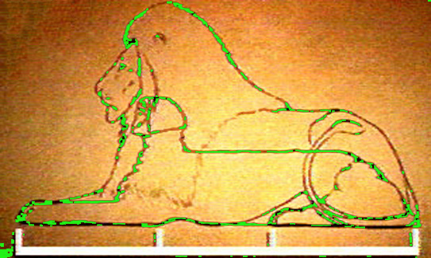
http://eden-saga.com/en/egyptology-gizeh-bauval-hancock-schoch-west-vs-zahi-hawass-1st-round-a-sphinx-war.html
2 Peter 3:5-6 (KJV)
⁵ For this they willingly are ignorant of, that by the word of God the heavens were of old, and the earth standing out of the water and in the water: ⁶ Whereby the world that then was, being overflowed with water, perished:

(NLT)
⁵ They deliberately forget that God made the heavens long ago by the word of his command, and he brought the earth out from the water and surrounded it with water. ⁶ Then he used the water to destroy the ancient world with a mighty flood.

Satan’s plan was to “be like God” and to rise above God.

This shows us that even angels have a free will

One Third WILL fall in the future

The question arises, if Jesus made everything as the Bible says He did. Did He create sin? Sin is more of a mindset than it is a physical thing.

We, almost always, know when we are going to sin before we do.

From that moment on, what has been Satan’s plan?

John 10:10 (NLT)
The thief's purpose is to steal and kill and destroy. My purpose is to give them a rich and satisfying life.

Dake's Study Notes - Ps 109:6 The Doctrine of Satan
In general, his work is to oppose God whenever possible. For this reason his work varies in some respects with the purposes of God in different ages and dispensations. In O.T. times Satan's great work was to cause the fall of man, usurp his dominion, and try to prevent the coming of the Messiah into the world in order to avert his own defeat and pending doom. See notes, Gen. 6:1-4. Note the following regarding Satan and his activities:
The Doctrine of Satan

What He Is Not:

Satan is not evil principle, an error of the mortal mind, an abstract power, or a being with hoofs, horns, and tail, holding a pitchfork and presiding over a lake of fire and the realm of the dead.

What He Is:

1. Satan is a real person (1Chr. 21:1; Job 1:6-12; 2:1-7; Ps. 109:6; Zech. 3:1-2; 1Pet. 5:8-9; Rev. 12:7-12)

2. Jesus dealt with him as with a person (Mt. 4:1-11; Lk. 4:1-13)

3. Jesus waged war on Satan as on a person (Lk. 13:16; Acts 10:38; 1Jn. 3:8)

4. Christ taught that Satan was a real person (Lk. 10:18; Rev. 12:7-12; 13:1-4; 20:1-10)

5. The apostles fought with Satan as with a real person (Eph. 6:10-18; 1Th. 2:18; 1Pet. 5:8-9)

6. The apostles warned men against a personal devil (Eph. 4:27; 6:11; Jas. 4:7; 1Pet. 5:8-9)

7. Personal singular pronouns are used of Satan (Mt. 4:7-11; 12:26; Lk. 11:18)

8. Personal statements are made to him (Job 1:6-12; 2:1-7; Isa. 14:12-14; Ezek. 28:11-17; Zech. 3:1-2; Mt. 4:1-10; Jude 1:9)

9. Personal conversation is carried on with him (Job 1:6-12; 2:1-7; Isa. 14:12-14; Mt. 4:1-10; Jude 1:9)

10. Personal descriptions are given of him (Isa. 14:12-14; Ezek. 28:11-17)

11. The personal names and titles that are given to him:

(1) Lucifer (Isa. 14:12-14)

(2) The Devil and Satan (Rev. 12:9)

(3) Beelzebub (Mt. 10:25; 12:24)

(4) Belial (2Cor. 6:15)

(5) The adversary (1Pet. 5:8-9)

(6) The dragon (Rev. 12:3-12; 13:1-4; 20:1-3)

(7) The serpent (2Cor. 11:3; Rev. 12:9)

(8) The god of this world (2Cor. 4:4)

(9) The prince of this world (Jn. 12:31)

(10) The prince of the power of the air (Eph. 2:1-3)

(11) The accuser of our brethren (Rev. 12:10)

(12) The enemy (Mt. 13:39)

(13) The tempter (Mt. 4:3)

(14) The wicked one (Mt. 13:19,38)

(15) That wicked one (1Jn. 5:18)

12. Personal acts and attributes are ascribed to him (see The Doctrine of Satan)

13. He is an angel with a body, soul, and spirit like all other angels (Ezek. 28:11-17; Rev. 12:7-12)

14. He is described as a most beautiful creature who fell through personal pride over his own beauty (Ezek. 28:11-17; 1Tim. 3:6)

15. He has been seen with a body (1Chr. 21:1; Job 1:6-12; 2:1-7; Ps. 109:6; Zech. 3:1-2; Mt. 4:1-11; Rev. 20:1-3)

16. He will be bound physically with a chain and cast into a prison (Rev. 20:1-3)

17. He has a heart (Isa. 14:12-14); pride (Ezek. 28:17; 1Tim. 3:6); speech (Job 1:6-12; 2:1-7; Mt. 4:1-11); knowledge (Job 1:6-12; 2:1-7; Mt. 4:1-11; Rev. 12:12); power (Job 1:6-22; 2:1-7; Acts 10:38; 26:18; 2Th. 2:8-12; Rev. 13:1-4); desires (Lk. 22:31); lusts (Jn. 8:44; Eph. 2:1-3); and many other physical parts, soul passions, and spirit faculties

18. He goes from place to place in a body like anyone else (Job 1:6-12; 2:1-7; Mt. 4:10-11; Mk. 4:15)

19. He has a kingdom (Mk. 3:22-26)

20. He has access to heaven (Job 1:6-12; 2:1-6; Rev. 12:9-12)

21. He is a great celestial and terrestrial ruler (Jn. 12:31; 2Cor. 4:4; Eph. 2:2; 6:10-18)

22. He rules the business, social, political, and religious activities of the majority of mankind

23. His realm is divided into organized principalities and powers in the heavenlies (Dan. 10:12 -- Dan. 11:1; Mt. 12:24-30; Eph. 6:10-12)

24. His subjects are fallen angels, fallen men, and demons of various kinds (Mt. 25:41; Jn. 8:44; Jas. 2:19; 1Jn. 3:8-10; Rev. 12:7-12)

25. He is head of some religions and is a leader in religious affairs (2Cor. 11:14; 2:9; 3:9)

The Origin of Satan:

Satan was created by Christ along with other beings, principalities and powers in heaven and earth (Job 38:4-7; Ezek. 28:11-17; Col. 1:15-18).

Satan First Ruler of Earth:

According to Isa. 14:12-14; Jer. 4:23-26; Ezek. 28:11-17; Lk. 10:18; 2Pet. 3:4-8 and other passages, Satan (also known as Lucifer) had a kingdom on earth long before the six days of Gen. 1:3 -- Gen. 2:25 and the creation of Adam. These passages reveal that he fell, led an invasion into heaven and was defeated. At that time the earth was cursed and all life destroyed by the first flood (Gen. 1:2). Satan regained rulership over the earth in Adam's day, usurping man's dominion by causing his fall. His relationship to man through the ages has been that of a usurper; and as long as man tolerates his dictatorship he will remain subject to Satan. Each man can now, by the power of the gospel, defeat Satan and rid himself of all demon relationship. This is what God demands, and He has provided means whereby it can be attained (Mk. 16:17-18; Lk. 10:19; 24:49; Acts 1:8; Eph. 6:10-18; Jas. 4:7; 1Pet. 5:8-9). Satan's present position as ruler of this world's system and as the prince of this world will be ended forever when Christ comes (Rev. 19-20), and man will again inherit the earth and live on it forever.

The Fall of Satan:

Several clear scriptures describe this. He fell through pride over his own beauty (Ezek. 28:11-17; 1Tim. 3:6), and trying to exalt himself above God (Isa. 14:12-14).

The Work of Satan:

In general, his work is to oppose God whenever possible. For this reason his work varies in some respects with the purposes of God in different ages and dispensations. In O.T. times Satan's great work was to cause the fall of man, usurp his dominion, and try to prevent the coming of the Messiah into the world in order to avert his own defeat and pending doom. See notes, Gen. 6:1-4. Note the following regarding Satan and his activities:

Twenty-six Branches of Satan's Work:

1. He is the deceiver of all mankind (2Cor. 11:14; Rev. 12:9; 20:1-10).

2. He exercised the power of death until Christ conquered death, hell, and the grave (Heb. 2:14; Rev. 1:18).

3. He is the leader of all sinners and backsliders of the human race (1Jn. 3:8-10; 1Tim. 5:15), and all spirit rebels (Mt. 9:34; Eph. 6:10-18).

4. He causes all sickness, disease, and physical and mental maladies in the human race (Lk. 13:16; Acts 10:38).

5. He takes advantage of all adversities of men to further their rebellion and hold them captive (2Cor. 2:11; 1Tim. 1:20; 5:11-15).

6. He tempts men (Mk. 1:13; 1Cor. 7:5).

7. He provokes to sin (1Chr. 21:1).

8. He causes offense (Mt. 16:23).

9. He transforms himself into an angel of light (2Cor. 11:14).

10. He resists others (Zech. 3:1-2).

11. He enters into union with others against God (Lk. 22:3; Jn. 13:2).

12. He sends messengers to defeat saints (2Cor. 12:7).

13. He hinders the gospel (Acts 13:10; 1Th. 2:18).

14. He steals the Word of God from men lest they should believe it (Mt. 13:19; Lk. 8:12).

15. He works miracles (2Th. 2:9).

16. He contends with messengers of God, endeavoring to hold them captive (Dan. 10:12-21; Jude 1:9).

17. He hinders answers to prayer (Dan. 10:12-21).

18. He sets snares for men to fall into sin (1Tim. 3:7; 2Tim. 2:26).

19. He causes diversion and blinds men to the gospel (2Cor. 4:4).

20. He causes double-mindedness (Jas. 1:5-9).

21. He causes doubt and unbelief (Gen. 3:4-5; Rom. 14:23).

22. He causes darkness and oppression (2Cor. 4:4; 2Pet. 1:4-9).

23. He causes deadness and weakness (Heb. 6:1; 9:14).

24. He causes delay and compromise (Acts 24:25; 26:28).

25. He causes divisions and strife (1Cor. 3:1-3; 1Pet. 5:8).

26. He makes war on the saints (Eph. 6:10-18).

War on the Saints:

The greatest and most important work of Satan among men now is to counterfeit the doctrines and experiences of God as revealed in Scripture, in order to deceive saints (2Cor. 11:14-15; Eph. 6:10-18; 1Tim. 4:1-7; Rev. 12:9-12). Men are commanded to prove and test all doctrines and experiences in the supernatural realm to see if they are of God or of Satan (1Cor. 2:12-16; Php. 1:9-10; 1Th. 5:21-22; 1Jn. 4:1-6). It is certain that every religion, doctrine, and experience among men cannot be of God. We must, therefore, judge them by the written Word of God. The knowledge of truth is the first essential in warfare against demons and error. Great is the danger when believers accept anything and everything in the realm of the supernatural as being from the Lord. The fact that the believer is a child of God does not stop the devil from trying in every conceivable way to imitate God to deceive him. Believers are the ones Satan concentrates on and wars against.

There are definite ways outlined in Scripture whereby one can detect what kind of spirit is seeking to control him. But if one neglects to study the Word he may fall prey to one of Satan's demons through ignorance. It must be realized that ignorance is no guarantee against workings of evil spirits. In fact, one of the chief means by which Satan and his forces try to control men is through ignorance. It accounts for their widespread success in getting men to accept their suggestions, doctrines, ideas, leadings, and guidance. Among the guiding principles useful in detecting good and evil spirits, and their operations and doctrines, the outstanding ones are these:

1. Any doctrine that denies or causes doubt and unbelief concerning anything taught in Scripture is from Satan and his demons (1Tim. 4:1-8). Any religion denying the inspiration of the Bible; the reality of God as a person; the virgin birth and divinity of Christ; His miraculous power and supernatural ministry; the death, burial, physical resurrection, and physical manifestation of Christ after His resurrection; the physical ascension to heaven and coming again of Jesus Christ to set up a kingdom in the world forever; the necessity of the new birth, cleansing from sin and living free from sin; and the numerous other experiences of the Bible -- any religion denying these fundamental truths is yielding to "the spirit of error," not "the spirit of truth" (1Jn. 4:1-6).

2. Any power, influence, or doctrine that causes one to become passive, inactive, submissive, and unresisting to the workings of supernatural spirits seeking to control his life contrary to the teachings of Scripture, is not of God. The Bible says, "Resist the devil" (Jas. 4:7; 1Pet. 5:8-9). An inclination to approve sin and ignore the necessity of repentance and holy living, and a tendency to remove the penalty for sin or doubt that hell is literal and eternal, is promoted by Satan, not God. Just as God requires truth in the mind for the true working of the Holy Spirit in a life, so the devil requires the believing of lies in the minds of men to hold them in bondage. See 1Cor. 6:9-11; 10:12-13; 2Cor. 11:3-15; Gal. 5:19-21; 6:7-8; Eph. 6:10-18; 1Tim. 4:1-9; Jas. 1:22; 2:10.

3. The Holy Spirit can be recognized by the fruit of the Spirit: love, joy, peace, longsuffering, gentleness, goodness, faith, meekness, and temperance (Gal. 5:22-23).

Six Earmarks of a Manifestation of the Holy Spirit:

(1) A Christ-like spirit of love, patience, and faith in God

(2) Soberness and keenness of spirit vision

(3) Deep humility of heart and meekness of spirit, with a lion-like courage against sin, sickness, poverty, disease, discouragement, failure, and everything else causing defeat in the Christian life

(4) Absolute clearness of the mental faculties and intelligent action in carrying out Biblical instructions concerning known duty and personal life as a Christian

(5) Freedom from faultfinding, surmising, whispering, and slander; and freedom from all the works of the flesh listed in Mk. 7:19-21; Rom. 1:24-32; 1Cor. 6:9-11; Gal. 5:19-21; Col. 3:5-10

(6) Freedom from any ignorance concerning the divine will. When one is moved upon to act quickly and urgently without knowing whether the act will glorify God or not, it is better to wait and pray until it is clear beyond all doubt that God approves such action. Always remember that 1Jn. 4:1 commands: "Try the spirits whether they are of God."

The Character of Satan:

The names and various descriptions of Satan reveal his true character as follows:

1. He is the enemy of all good and the accuser of God and man (Ezek. 28:11-17; Mt. 13:28; Rev. 12:9-12).

2. The father of lies (Jn. 8:44)

3. A murderer (Jn. 8:44)

4. A sower of discord (Mt. 13:39)

5. An adversary (1Pet. 5:8-9)

6. The first sinner, the first rebel, and the first to consecrate himself to self-gratification and to wage war against all society (Isa. 14:12-14; Ezek. 28:11-17; Rev. 12:9; 20:7-10)

7. He is cunning (2Cor. 2:11; 11:14; Eph. 6:11-12).

8. Wicked (Mt. 13:18,38; Jn. 8:44; 1Jn. 3:8; 5:18)

9. Malignant (Lk. 8:12; 2Cor. 4:4; 1Pet. 5:8-9)

10. Cowardly (Jas. 4:7)

11. Tempter (Mt. 4:1-11)

12. Thief (Jn. 10:10)

13. Without principle in taking advantage of people in their weak moments (Mt. 4:1-11; Lk. 22:40; 2Cor. 2:11; 11:3); in tempting people after great success (Jn. 6:15); in suggesting the use of right things in a wrong way and at a wrong time (Mt. 4:1-11); in slandering God to man and man to God (Gen. 3:1-10; Job 1:6-12; 2:1-7); in appearing as an angel of light to deceive (2Cor. 11:14); and in deluding his followers as to their eternal end (2Th. 2:8-12; Rev. 12:9; 20:7-10)

14. Presumptuous (Job 1:6-12; 2:1-7)

15. Proud (Ezek. 28:17; 1Tim. 3:6)

16. Deceitful (2Cor. 11:14; Rev. 12:9; 20:10)

17. Fierce and cruel (Lk. 8:29; 9:39; 1Pet. 5:8-9)

18. Aggressive (Eph. 4:27; 6:10-18; 1Pet. 5:8-9)

Satan has never been known to be merciful, good, loving, kind, gentle, pitiful, patient, or to have any of the graces of God since he became the enemy of God and man. In Scripture he is compared to a fowler (Ps. 91:3); fowl (Mt. 13:4,19); a wolf (Jn. 10:12); a destroyer (Jn. 10:10); a roaring lion (1Pet. 5:8-9); a serpent (Rev. 12:9; 20:3); and a dragon (Rev. 12:3-12).

The methods of Satan:

1. He uses every conceivable means to hold men in subjection to himself and keep them from turning to God. If he fails in this, he tries to kill the believer's testimony and ruin his influence for God.

2. If one falls he tries to make him stay fallen or commit suicide. He endeavors to cause men to end their lives by insisting it is the best way out; but he hides the true fact that this will be only the beginning of real torment in eternal hell.

3. Satan tries to get others in a lukewarm condition and, if he succeeds, urges them to stay in that condition so that God will cut them off in the end.

4. He dares men to do many things which they would not do under ordinary circumstances; and men are foolish enough to think they are not brave if they do not accept his dares.

5. Makes people think they are missing everything in life if they do not go into all kinds of sins which, in the end, will damn their souls.

6. He emphasizes sin and sinful pleasures as innocent enjoyment.

7. He stirs unholy passions in men and women, causing them to throw away all restraint and live a life of revelry.

8. He tries to make people think there is no joy in serving the Lord. This is one of his greatest errors. Serving Christ and winning souls pays the greatest dividends and offers the greatest pleasures known.

9. He preaches to the diligent in business that he needs to invest all his time in getting rich before serving the Lord. The fact is that if one will truly serve the Lord, he can be abundantly prosperous with God's help.

10. He urges churches and their leaders to make religion a paying proposition by appealing to the rich and influential through lowering the standards of holy living, making salvation easy for all, and compromising essentials of the faith; and by feeding the sheep messages on current events and book reviews instead of the infallible Word of God.

God's Purpose in Allowing Satan to Continue:

1. To develop character and faith in the believer (Jas. 1:12; 1Pet. 1:7-13; 5:8-9; 2Pet. 1:4-9; Jude 1:20-24)

2. To keep the believer humble (2Cor. 12:7)

3. To provide a conflict for saints that they may be rewarded through overcoming (1Jn. 2:13; 4:1-6; Rev. 2:7,11,17,26-28; 3:5,12,21)

4. To demonstrate the power of God over the power of Satan (Mk. 16:17-20; 2Cor. 4:7-11; Eph. 2:7; 3:10)

5. To use him in afflicting people to bring them to repentance (1Cor. 5:1-6; 2Cor. 2:5-11; Job 33:14-30)

6. To purge man of all possibility of falling in the eternal future (Rev. 21)

The Doom of Satan:

1. Predicted in Gen. 3:15

2. Accomplished:

(1) At the first advent (Jn. 19:30; Col. 2:14-17)

(2) At the second advent (Rev. 20:1-3)

(3) At the battle of Gog and Magog (Rev. 20:7-10)

The purpose of the thousand-year reign of Christ after the second coming will be to suppress all rebellion (1Cor. 15:24-28); and the final defeat of Satan and his hosts at the end of the Millennium must be accomplished before the earth is entirely rid of rebels. They must be confined to the lake of fire forever before rebellion is finally and eternally overcome. The earth will be purified by fire and made perfect the third time; and the kingdom of God will be universal over all free moral agents, as it was before rebellion was started by Satan and Adam in their respective kingdoms.

Duty of Saints Regarding Satan:

When one is born again he enters the realm of the supernatural and spiritual; he should begin a study of the Bible to see what it teaches regarding how he should walk and conduct himself in spiritual warfare with Satan and demons. Saints are to:

1. Put on the whole armor of God (Eph. 6:11-18).

2. Know Satan's devices (2Cor. 2:11).

3. Give him no place (Eph. 4:27).

4. Resist him (Jas. 4:7; 1Pet. 5:8-9).

5. Be sober and vigilant lest he devour them (1Pet. 5:8-9).

6. Overcome him by the Word (Mt. 4:1-11; 1Jn. 2:14).

7. Overcome him by the blood of Christ and testimony (Rev. 12:11).

8. Overcome him by Christ and His name (Eph. 1:19-22; 2:6; 2Cor. 2:15).

9. Overcome him by birth of the Spirit and faith (1Jn. 2:29; 3:9; 5:1-4,18).

10. Overcome him by the Holy Spirit (Rom. 8:1-13; Gal. 5:15-26).
Dake's Annotated Reference Bible: Containing the Old and New Testaments of the Authorized or King James Version Text.

