Mission for the Truth Sowers Life Group

- My Testimony
  - Received Christ at the age of 13
    - Wayne Garrett said, “There is only one thing that is free, salvation.”
    - Tried to live for Christ for approximately one year.
    - Had no one to mentor me or disciple me.
    - Fell away from the Lord after one year.
    - David had cancer and we talked about healing.
    - James 5: ¹⁴ Is anyone among you sick? Let them call the elders of the church to pray over them and anoint them with oil in the name of the Lord. ¹⁵ And the prayer offered in faith will make the sick person well; the Lord will raise them up. If they have sinned, they will be forgiven.
    - Baptist pastor, “Well, we don’t believe that.”
    - Gave my life back to the Lord at age 18.
    - Two weeks later, baptized in the Holy Spirit – HUGE change in my life!
- My Ministerial Resume
  - Resume See Attached Resume
- My Vision for Truth Sowers
  - Continue with much of what has gone on in Truth Sowers up to this point.
    - Truth Sowers has a four pronged foundation:
      - Teaching
      - Fellowship (among each other and to newcomers)
      - Ministry (painting, shoes, backpacks, etc.)
      - Prayer
    - I want to continue each of these foundations.
  - Prayer and Praise time. I want to continue this but move it to the end of the class. I also want to teach on prayer at some time in the future. Starla has been good at making sure the prayer and praise requests get out to everyone in the class in addition to prayer that is requested during the week.
We will try to end the class, no later than, 10:30am.
  - Fellowship among class members and greeting newcomers has always been an important part of Truth Sowers and I want to continue that. Gale has very good to send out cards to newcomers, to take role and set up socials.
  - I would like to see us continue our ministry as a class. I would like to know who feels called to pursue this part of the ministry for the class.
    - Homeless ministry
    - Your suggestions
  - I am excited to be able to teach.
    - Steve has agreed to step up once a month to teach.
    - Barbara and I want to take one week off each month to keep from getting burned out and so that we can either sit and learn or do something together.
    - I will use a combination of expository and topical teaching.
      - Expository – Throwing light upon the meaning of a particular text or passage of Scripture. Going through books of the Bible like Jim did.
      - Topical – Teaching on certain topics.
    - Isaiah 55: ¹¹ So shall my word be that goeth forth out of my mouth: it shall not return unto me void, but it shall accomplish that which I please, and it shall prosper in the thing whereto I sent it.
      - The Word of God is very important. The Word is what will change your life.
    - 1 Timothy 4: ¹⁶ Take heed unto thyself, and unto the doctrine; continue in them: for in doing this thou shalt both save thyself, and them that hear thee.
      - I take this role very seriously and will do my best to pray and study and present the Word to you in all seriousness.
    - In the ESSENTIALS – UNITY; in the NON-ESSENTIALS – LIBERTY
      - This does not mean that the “Non-Essentials” are not important.
    - My main goal is to see YOU grow spiritually through the teaching of the Word of God.
    - I also want to make it fun for you to learn.
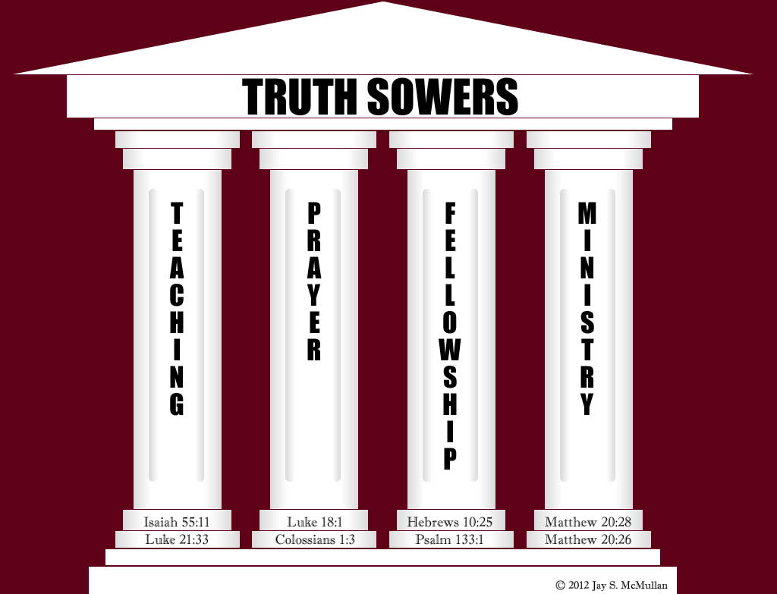
- We want to start Care Groups.
  - These will be small groups in specific areas of Central Florida.
  - Get together once a month.
  - Be, as Ray said, “First Responders” when someone is sick or needs help.
- Have Socials once a quarter where all care groups and all members come together..3

